AskVer
Enterprise Deal Intelligence Platform

Team: Velocity
Contributors: Kartik Rehan, Jigyasu Khera

1. Idea Snapshot
Idea title
AskVer — Enterprise Deal Intelligence Platform
One-line pitch
AskVer is an AI-powered platform that brings together client intelligence, organizational knowledge, sales activity, and meeting insights into a single view of an enterprise deal.
Team / Domain / Users
AskVer is designed for enterprise sales, consulting, technology services, and strategic account management. Its primary users are CXOs, Directors, Partners, Business Heads, and other senior executives involved in strategic deals, while sales, BD, pre-sales, and account teams can contribute and use deal information.

2. Problem / Opportunity
Who are you helping?
AskVer helps senior executives quickly understand and manage strategic enterprise opportunities, while connecting them with the sales and deal teams working on those opportunities.
What is the problem?
The information required to understand a deal is often scattered across client research, industry reports, proposals, case studies, emails, meeting notes, presentations, internal knowledge, and individual employee experience. Senior leaders often have limited time to reconstruct this context before an important client conversation.

What is inefficient today?
Teams repeatedly spend time researching accounts, finding relevant internal capabilities, preparing meeting briefs, and consolidating information for management. Important meeting insights and lessons from previous deals can also remain isolated instead of becoming reusable organizational knowledge.
What is the opportunity?
AskVer brings this information together around one central deal record, creating a continuous intelligence workflow from research and preparation to meetings, follow-ups, and deal outcomes.

3. Better Outcome — What Changes?
What changes with AskVer?
We are helping senior executives and deal teams move from fragmented deal information to a continuous source of intelligence around every strategic opportunity.
AskVer connects:
Client Intelligence → Internal Knowledge → Deal Understanding → Meeting Preparation → Client Conversation → Meeting Analysis → Actions → Outcome & Learning
Before a meeting, executives can quickly understand the client, priorities, stakeholders, relevant capabilities, and potential concerns. After the meeting, AskVer captures key discussions, actions, opportunities, and concerns and adds them back to the deal record. Over time, this creates a complete history that can also support learning from won and lost opportunities.
What is the key change?
Instead of being just an AI assistant or research tool, AskVer becomes the intelligence layer that follows the deal throughout its lifecycle.

4. How OpenAI / Codex Enables It
What role does OpenAI play?
AskVer will be powered by OpenAI models for reasoning, information synthesis, retrieval, analysis, and intelligent workflows. The goal is not simply to generate summaries, but to connect information from different sources and turn it into useful deal intelligence.
What will the AI do?
AskVer can automate workflows such as client research, industry analysis, internal knowledge retrieval, capability matching, executive brief generation, meeting analysis, action extraction, and deal-outcome analysis.
For example, a user could ask:
“Prepare this deal for next week’s client discussion.”
AskVer can gather relevant information, retrieve supporting internal evidence, analyze the opportunity, and produce a concise, evidence-grounded deal brief.
What role does Codex play?
Codex will support the implementation and development of AskVer, helping build the backend, workflows, integrations, and application components. OpenAI models provide the intelligence layer, while Codex helps accelerate the engineering required to turn that intelligence into a working enterprise platform.
Technology stack
OpenAI Models → AI & Reasoning
Codex → Implementation
LangGraph → Workflow Orchestration
FastAPI → Backend
PostgreSQL / ChromaDB → Deal & Knowledge Data
React → User Interface

5. Expected Impact & Evidence
- Revenue Growth & Higher Win Rates
  - Impact: Sharper prep and better client intelligence help executive teams lead stronger conversations, boosting win rates on high-value enterprise deals.
  - Evidence: A measurable increase in deal win rates and shorter sales cycle times.

- Cost Reduction & Time Savings
  - Impact: Cuts down expensive pre-sales and executive hours spent digging through scattered documents and manually drafting meeting briefs.

  - Evidence: Executive brief creation time drops from several hours to under 2 minutes, directly lowering labor cost per deal.

- Productivity & Knowledge Reuse
  - Impact: Automatically surfaces relevant past proposals, case studies, and win/loss lessons so teams don't waste time reinventing the wheel.

  - Evidence: High accuracy in AI-matched capabilities and high daily adoption rates across CXOs and senior leaders.

Simple Summary and Workflow
AskVer is an AI-powered platform that helps companies prepare and manage important business deals.
First, a company creates its AskVer account and uploads its own knowledge, such as case studies, capabilities, past proposals, services, and other company documents.
Then, the user creates a Deal and uploads documents related to the target company, such as the RFP, business documents, requirements, presentations, and other available information.
Once the deal is created, AskVer starts an AI-powered workflow:
1. Company Research
AskVer researches the target company and creates an overall company overview, including its business, industry, key priorities, products/services, and important developments.
2. Financial Analysis
It analyzes available financial information such as revenue, growth, profitability, business segments, and other relevant financial indicators to understand the company's current position.
3. Business & Industry Analysis
AskVer studies the company's industry, competitors, market situation, challenges, strategy, and potential areas where the company may need help.
4. Deal & Requirement Analysis
It analyzes the uploaded RFP and other deal documents to understand what the client is asking for, their requirements, priorities, challenges, and decision criteria.
5. Match With Our Capabilities
AskVer compares the client's requirements with the company's uploaded case studies, capabilities, services, and previous experience to identify relevant solutions and supporting evidence.
6. Deal Intelligence Report
All the research is combined into one comprehensive deal report that gives the user a clear understanding of the client, opportunity, requirements, risks, and potential approach.
7. Meeting Preparation
AskVer then prepares the team for the client conversation by generating meeting pitches, key talking points, questions to ask, potential objections, counterpoints, concerns, risks, and recommended responses.
8. Chat With the Report
Instead of reading the entire report manually, users can chat with the final report and ask questions such as:
"What are the client's biggest concerns?"
"Which of our case studies is most relevant?"
"What questions should I ask the CXO?"
"What objections should we expect?"
"Summarize the financial situation."

Prototype:
Upload your company knowledge →
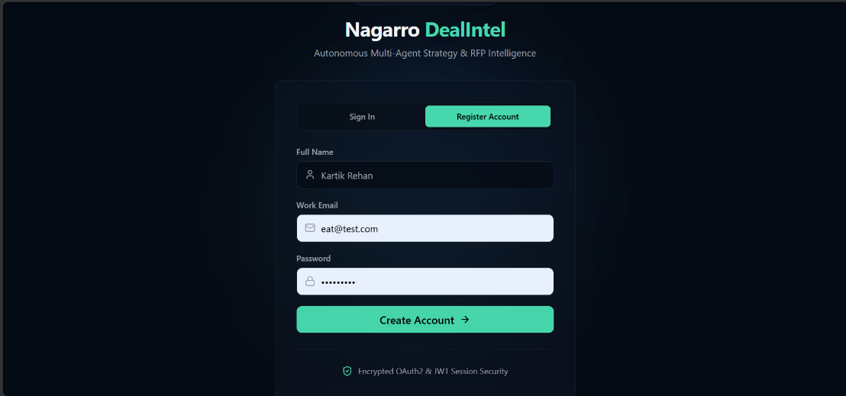
Create a deal →
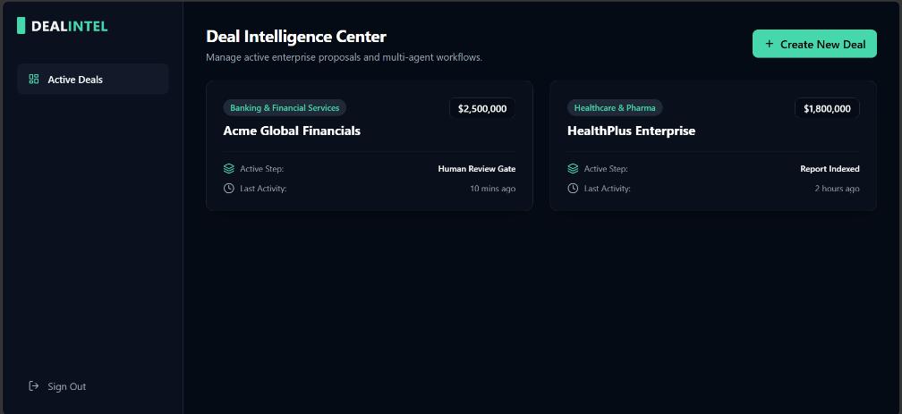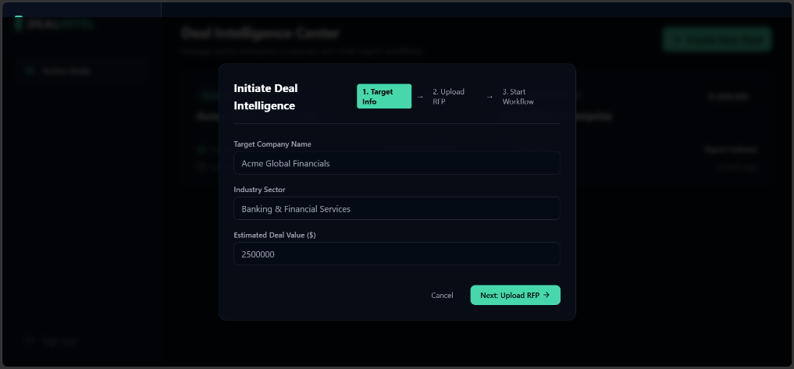
Upload client documents → 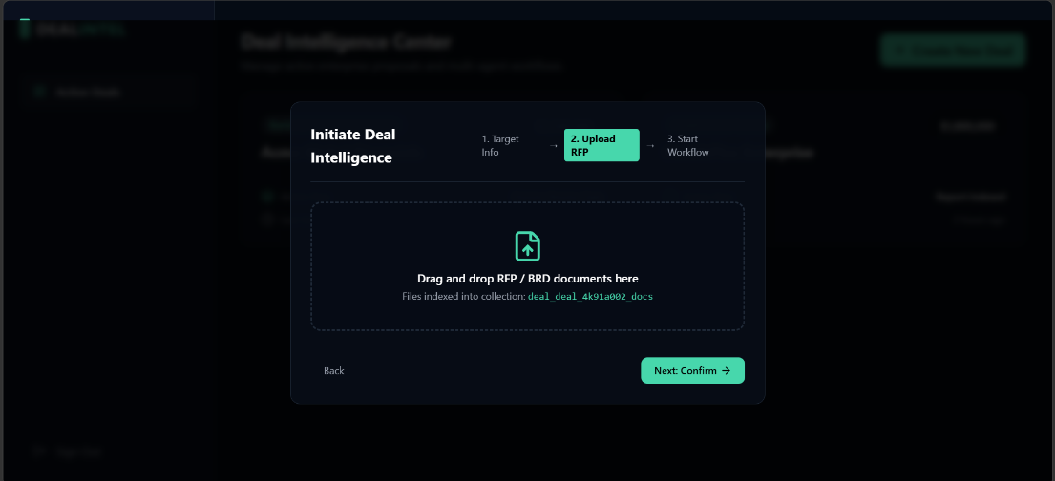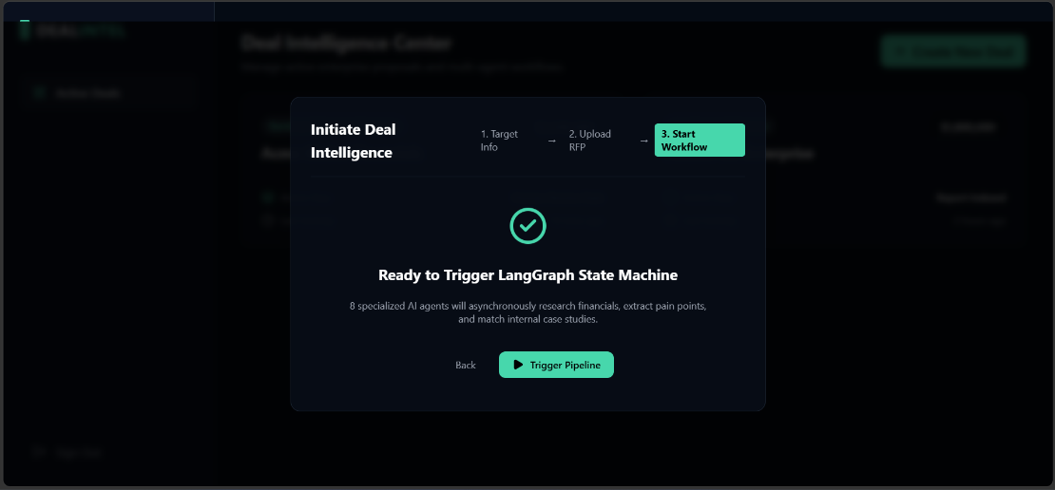
AskVer researches and analyzes the company → Understands the deal → Matches your capabilities → Prepares the meeting →
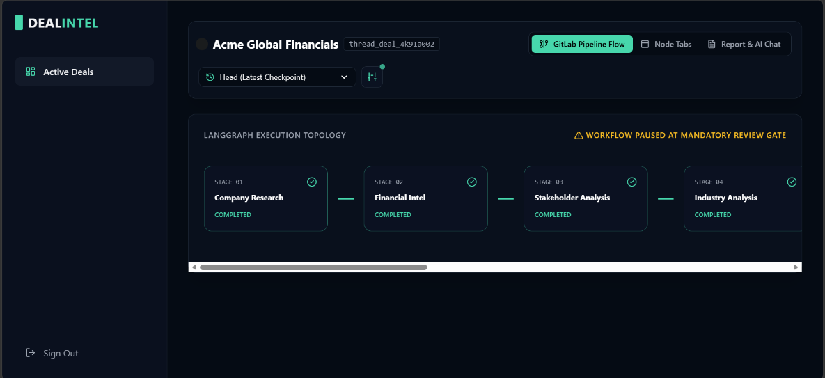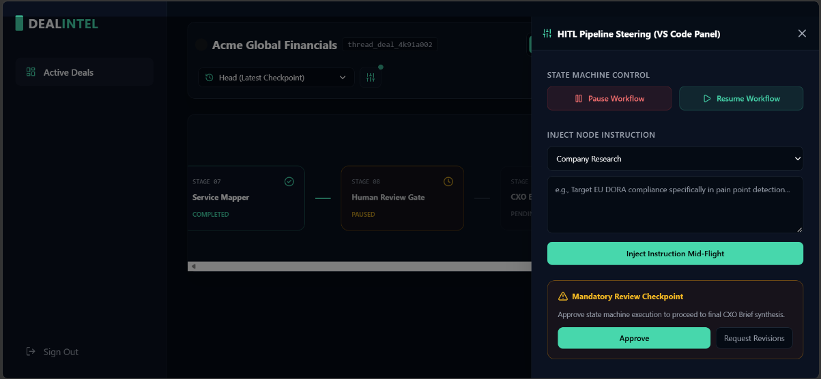
Lets you chat with the final intelligence report.
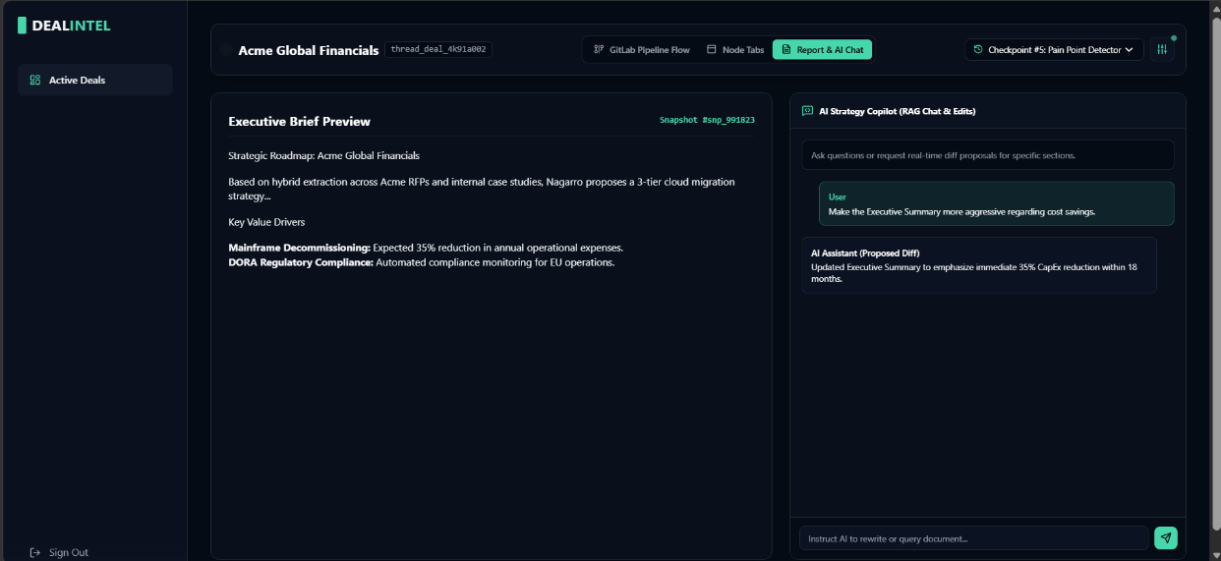
Disclaimer regarding visual assets: Please be advised that the screenshots included in this document display the project's initial title, "DealIntel" The project was rebranded to "Askver" prior to finalization.

